**A Project Report on**

**Buy It Now**

***In partial fulfilment for the award of the degree***

***Of***

**Master’s**

**In**

**Information System**

**Submitted By**

**Priyanka Nirpase (W1356392)**

**Aalap Doshi (W1353286)**

**Parvathi Varma Ramar Kovilakom (W1284667)**

**Jui Shaligram (W1360842)**

**Guided By**

**Prof. Yasser Dessouky**

**Assistant Professor**



**Information Systems Department**

**Leavey School of Business, Santa Clara University**

**500 El Camino Real**

**2017-2018**

**ACKNOWLEDGEMENT**

We have taken efforts in this project. However, it would not have been possible without the kind support and help of many individuals and organizations. We would like to extend our sincere thanks to all of them.

We are highly indebted to **Prof. Yessar Dessoucky** for their guidance and constant supervision as well as for providing necessary information regarding the project. We take this opportunity to thank all our friends and colleagues who started us out on the topic and provided extremely useful review feedback and for their all-time support and help in each and every aspect of the course of our project preparation. We are grateful to our college Santa Clara University, Santa Clara, CA for providing us all required resources and good working environment.

**Priyanka Nirapase (W1356392)**

**Aalap Doshi (W1353286)**

**Parvathi Varma Ramar Kovilakom(W1284667)**

**Jui Shaligram (W1360842)**

***ABSTRACT***

|  |  |
| --- | --- |
|  |  |

*Efficiency and speed are prime factors for a successful device. From qwerty to swipe and to voice command, technology has been rapidly evolving over time. Casper has used the latest technology of voice command that can enable one to talk to the system casually as you talk to your friend and at the same time get your work done in split seconds. The words are analysed as keywords that can then help the system understand the command and carry out the action.*

*This is a touch activated voice command system. This system uses location awareness and has the ability to manage mails, calendar, events, to-do list, and search for any information using voice as the primary interface.*

*The system will also be updated with many more services such as order-in food from restaurants, also reserves seats at restaurant, connect to 3rd party devices and enhancement for specially abled people also added with a function to book Uber rides, in near future.*

**Santa Clara University**

[UNDERTAKING ABOUT ORIGINALITY OF WORK]

We hereby certify that we are the sole authors of this project report and that neither any part of this project report nor the whole of the Project report has been submitted for a degree by other students to any other University or Institution.

We certify that, to the best of our knowledge, the current Project report does not infringe upon anyone’s copyright nor violate any proprietary rights and that any ideas, techniques, quotations or any other material from the work of other people included in our Project report, published or otherwise, are fully acknowledged in accordance with the standard referencing practices. Furthermore, to the extent that we have included copyrighted material that surpasses the boundary of fair dealing within the meaning of the American Copyright (Amendment) Act 2012, we certify that we have obtained a written permission from the copyright owner to include such materials in the current Project report and have included copies of such copyright clearances to our appendix.

We have checked the write up of the present Project report using anti-plagiarism database and it is in the allowable limit. In case of any complaints pertaining to plagiarism, we certify that we shall be solely responsible for the same and we understand that as per norms, University can even revoke Master’s degree conferred upon the students submitting this Project report, in case it is found to be plagiarised.

**Table Of Contents**

|  |  |  |  |  |
| --- | --- | --- | --- | --- |
|  | Acknowledgement | | | II |
|  | Abstract | | | III |
|  | Certificate | | | IV |
|  | UnderTaking Form | | | VII |
|  | Contents | | | VIII |
|  | List of Figures | | | IX |
|  | List of Tables | | | X |
|  | Symbols And Abbreviations | | | XI |
|  | | | | |
| Chapter 1 | Introduction | | | 1 |
|  | 1.1 | Organization Profile | | 1 |
|  | 1.2 | Project Detail | | 1 |
|  |  | 1.2.1 | Project Profile | 1 |
|  |  | 1.2.2 | Project Definition | 2 |
|  | 1.3 | Purpose | | 2 |
|  | 1.4 | Scope | | 3 |
|  | 1.5 | Technology And Literature Review | | 3 |
| Chapter 2 | About The System | | | 4 |
|  | 2.1 | System Requirement Specification | | 4 |
|  | 2.2 | Feasibility Study | | 4 |
|  |  | 2.2.1 | Operational Feasibility | 5 |
|  |  | 2.2.2 | Technical Feasibility | 6 |
|  |  | 2.2.3 | Time Schedule Feasibility | 6 |
|  |  | 2.2.4 | Economical Schedule Feasibility | 6 |
|  |  | 2.2.5 | Implementation Feasibility | 7 |
|  | 2.3 | Project Planning | | 8 |
|  |  | 2.3.1 | Project Plan | 9 |
|  |  | 2.3.2 | Risk Management | 9 |
|  |  | 2.3.3 | Risk Identification | 9 |
| Chapter 3 | Analysis | | | 11 |
|  | 3.1 | E-R Diagram | | 11 |
|  | 3.2 | Data Flow Diagram | | 13 |
|  | 3.3 | Use Case Diagrams | | 17 |
|  | 3.4 | Sequence Diagram | | 19 |
|  | 3.5 | Activity Diagram | | 23 |
| Chapter 4 | Design | | | 28 |
|  | 4.1 | System Flow Diagram | | 28 |
|  | 4.2 | Data Dictionary | | 28 |
|  | 4.3 | Class Diagram(Relation of Table) | | 31 |
| Chapter 5 | Conclusion & Future Work | | | 32 |
|  | 5.1 | Conclusion | | 32 |
|  | 5.2 | Future Work | | 32 |
| Appendix A | Document of Hands on exercise on Different Types of Canvas | | | 33 |
|  | References | | | 38 |

**List of Figures**

|  |  |  |
| --- | --- | --- |
| **Figure Number** | **Description** | **Page Number** |
| Figure 2.1 | Project Development Approach | 8 |
| Figure 2.2 | Project Plan | 9 |
| Figure 3.1 | ER Diagram Player of MM Player | 12 |
| Figure 3.2 | Data Flow Diagram Level-0 | 14 |
| Figure 3.3 | Data Flow Diagram Level-1.1 | 14 |
| Figure 3.4 | Data Flow Diagram Level-1.2 | 14 |
| Figure 3.5 | Data Flow Diagram Level-1.3 | 14 |
| Figure 3.6 | Data Flow Diagram Level-1.4 | 15 |
| Figure 3.7 | Data Flow Diagram Level-1.5 | 15 |
| Figure 3.8 | Data Flow Diagram Level-1.6 | 15 |
| Figure 3.9 | Data Flow Diagram Level-1.7 | 15 |
| Figure 3.10 | Data Flow Diagram Level-1.8 | 16 |
| Figure 3.11 | Use Case Diagram for MM Player | 18 |
| Figure 3.12 | Sequence Diagram for MM Player | 20 |
| Figure 3.13 | Sequence Diagram for Playlist | 21 |
| Figure 3.14 | Sequence Diagram for Voice Success | 21 |
| Figure 3.15 | Sequence Diagram for Voice Failure | 21 |
| Figure 3.16 | Sequence Diagram for Share | 22 |
| Figure 3.17 | Sequence Diagram for Category/Playlist | 22 |
| Figure 3.18 | Activity Diagram for MM Player | 24 |
| Figure 3.19 | Activity Diagram for Music Listen | 25 |
| Figure 3.20 | Activity Diagram for Voice Command | 26 |
| Figure 3.21 | Activity Diagram for Share Music | 27 |
| Figure 4.1 | System Flow for Diagram | 28 |
| Figure 4.2 | Class Diagram for MM Player | 31 |

**List of Table**

|  |  |  |
| --- | --- | --- |
| **Table Number** | **Description** | **Page Number** |
| Table 1.1 | Project Profile | 1 |
| Table 3.1 | ER Diagram Symbols | 11 |
| Table 3.2 | Symbols of Data Flow Diagram | 15 |
| Table 3.3 | Use Case Diagram Symbols | 17 |
| Table 3.4 | Sequence Diagram Symbols | 19 |
| Table 3.5 | Activity Diagram Symbols | 25 |
| Table 4.1 | Data Dictionary Playlist_db | 28 |
| Table 4.2 | Data Dictionary Category_db | 29 |
| Table 4.3 | Data Dictionary Voice Command_db | 29 |
| Table 4.4 | Data Dictionary Login_db | 29 |
| Table 4.5 | Data Dictionary Lyrics_db | 29 |
| Table 4.6 | Data Dictionary Mapping_db | 30 |
| Table 4.7 | Data Dictionary Song_db | 30 |
| Table 4.8 | Use Case Diagram Symbols | 31 |

# Chapter:1 Introduction

## 1.1**Organization Profile:**



Buy it now was founded in 2012. Since then we have been delivering innovative business solutions to our clients globally. Our core beliefs are anchored in understanding the clients' business goals, objectives and solving complex problems with the most effective solutions as a true business partner. Our rich legacy is reflected in our client list with a strong trust shared between us. We bring together the best of both worlds - automation through our technology solutions, and efficiency through our back-office services.

With established offices in the USA and INDIA, over the past 4 years, Buy it now has successfully provided technology automation and back office solutions to various industries. This experience has been at the core of our ability to deliver solutions and services to enable our clients to succeed in the marketplace.

## 1.2 Project Detail:

### 1.1 Project Profile:

|  |  |
| --- | --- |
| Project Name: | Kasper |
| Developing For | Buy it Now |
| Team Size | 4 Members |
| Documentation | MS PowerPoint, MS Word, MS Visio, MS Excel, Axure, Lucid Charts |
| Tools | SQLite |
| Front End | ADT |
| Back End | SQLite |
| Internal Guide | Prof. Yessar Dessoucky |

**1.3 BUSINESS DESCRIPTION:**

* BuyItNow is basically an e-commerce and cloud computing company which sells several stuff such as books, appliances, electronic items, household items and so on.
* The company also produces range of its own smart electronic products like tablets, TV, etc.

**1.4 BUSINESS NEED:**

* To offer faster and efficient service to customers, BuyItNow introduced a new paid subscription service which provides free two-day shipping, free streaming of videos and movies and additional discounts.
* To promote this service and to provide multiple other features to users which will increase company’s revenue, substantially a new device called “Smart Personal assistant” needs to be developed.

**1.5 BUSINESS REQUIREMENTS:**

* The smart personal assistant will consist of below functionalities –

1. Capable of music playback, making to-do lists, setting alarms, streaming podcasts, playing audiobooks, and providing weather, traffic, and other real time information
2. Switching on or off lights on recognizing voice command.
3. Giving reminders for paying utility bills and reminding for unavailability or stock exhaustion of household items such as tissues, bounty dish wash etc.
4. It can schedule flight, book Uber, take food orders, set temperature, check fuel and battery level of the car
5. With a built-in speaker and camera, it will be able to recognize and communicate with different family members and do a range of other clever things like tell you the contents of your fridge or reading a recipe from the web. It will do a variety of tasks which makes the home smart.
6. This smart personal assistant can be integrated with various other third party systems which will take customer experience to new level. This device will be very useful to crippled and disabled people.

**1.6 BUSINESS VALUE:**

* With the promotion of paid membership service through smart personal assistant, more customers will get attracted and subscribe for this service.
* This service provides free shipping, additional discounts, free streaming of videos and movies and few products are available only to paid members
* Thus, with the services provided, customers tend to order more stuff than usual which increases sales. Customers can easily make their shopping list and place orders with merely using few voice commands.
* Increasing the variety and the range of products sold by BuyItNow makes it one of the largest e-commerce companies.

# Chapter:2 About The System

## 2.1 System Requirements Specification

**Minimum Hardware Requirements:**

1. Android device.

2. USB.

3.IOS

**Minimum Software Requirements:**

1. Operating System**:** Windows XP or later

3. Application Software: ADT for Eclipse

4. Languages: Java, XML

5. Data Base**:** SQL Server, SQLite

6. Java Software: JDK

**Developer side Requirements**

1. Operating System**:** Windows.
2. Application Software: ADT for Eclipse.
3. Languages: Java, XML.
4. Data Base**:** SQLite, SQL Server.
5. Java Software: JDK

## 2.2ProjectPlanning

### 2.2.1 Project Development Approach

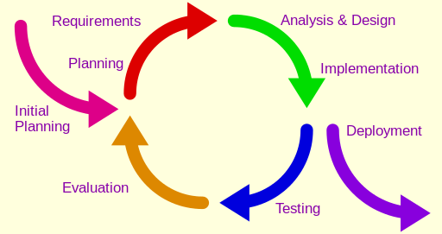

Diagram 2.1 Iterative Model

#### Why we choose this approach:

* In iterative model we are building and improving the product step by step. Hence we can track the defects at early stages. This avoids the downward flow of the defects.
* In iterative model we can get the reliable user feedback. When presenting sketches and blueprints of the product to users for their feedback, we are effectively asking them to imagine how the product will work.
* In iterative model less time is spent on documenting and more time is given for designing.
* Requirements of the complete system are clearly defined and understood.

### 2.2.2 Project Plan-GANTT Chart

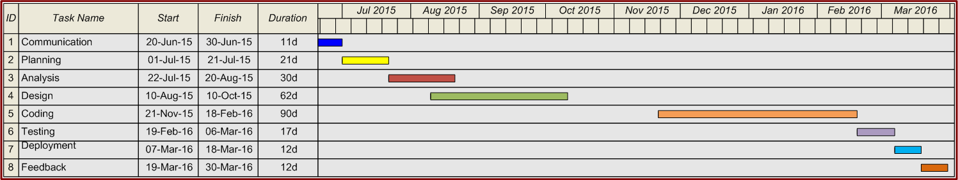

Diagram 2.2 Sample Gantt Chart

# Chapter:3 Analysis

**3.1 Functional Requirements and Non-functional Requirements**

**Set Reminders and alarms**

* The system will enable the user to set alarm for time specified.
* The system will repeat the timings of the alarm on user’s request.
* The system will enable the user to snooze the alarm on user’s request.
* The system will enable the user to create reminders (events, bill due date, medicine intake time etc.) and alert the user on the time specified.
* The system will enable the user to cancel any set alarms or reminders.

**Switch** **On**/**Off** **Lights**

* The system will enable the user to connect the lights to system using Wi-Fi.
* The system will notify the user through voice message in case the specified lights have not been connected to it.
* The system will enable the user to create different name for the different lights connected.
* The system will enable the user to switch on/off the lights specified.

·

**Music** **playback**

* System will play music from a chosen database.
* System will also play according to your mood.
* System will allow the user to add music to its library.
* System will also keep track of your favorite music.
* It will also allow user to play music according to the music artist.

User Requirement:

The user has to give voice commands in order to request system to perform the activities.

The application for BuyItNow has to installed in mobile to set up the Wi-Fi connections to switches.

The User has to wake the system by pressing on the “Microphone” add on before passing the voice commands.

**Place Order with BuyItNow**

·         System will allow users to handle all the orders via voice commands.

·         System will find the best product match as per user’s requirement conveyed through voice commands.

·         System will be able to recognize user’s commands to find best suitable product based on reviews and ratings.

·         System will allow users to place orders with BuyItNow via voice commands.

·         System will collaborate with user’s BuyItNow account to get user information including payment information

·         System will be able to read order status to users when asked.

·         System will allow user to cancel the order by just saying “Cancel” word.

·         System will let user browse through orders history and will tell them all the necessary details regarding any particular order.

·         System will provide recommendation about a particular product when user asks for it.

**Provide information like current time, weather, traffic and other real time information:**

·         System will allow the user to search for any information on a particular search engine

(ex -  Google) by using voice commands.

·         System will provide the best real time information of weather, traffic or any real time information to the user by getting outputs from the search engine.

·         System will provide the details of any information which the user searches for.

·         System will provide the list of restaurants or grocery stores available nearby or whichever location the user requires and also provide recommendations on which is the best to opt.

·         System will give a message to the user such as ‘Question was not understood or precise information is not available on this topic’ in case it was not able to properly interpret the user’s question.

**Account Creation and notification:**

* The system will enable user to sign in to mobile App using mail ID used for BuyITNow Account
* The system will enable user to create new account in BuyItNow using mobile App with a valid email ID
* The system will enable user to choose notification tone for various functionality eg.alarm tone, remainder tone,message tone etc.
* The system will enable user to set preferred music player  and priority of search engines
* The system will provide a guide to the user to use the personal assistant voice command tool
* The system will enable the user to view all the requests the user has filed with the system

**System Updation For Alarms, Reminders and Events:**

* The system updates the alarm time or  the time when the alarm is to be repeated  in alarm database on user’s request and now the alarm rings on the updated time.
* The system updates the alarm database when the user snoozes the alarm and the alarm rings after some interval.
* The system updates the reminders in the reminder database and alerts the user on the new time specified.
* The system updates the  alarm database or reminder database if a user cancels them.

**Non-functional Requirements**

* + - 1. **Operation**
  1. System will be accessible on any platform i.e. iOS, Android etc.
  2. System can be integrated for browsing function only with Safari, Chrome or Opera browser.
  3. System would be accessible from any device which will have internet connectivity and other necessary system requirements
  4. User account and relevant data will be accessible on the new phone if user has got a new phone.
     + 1. **Performance**

1. System will have 5 seconds of maximum response time for any voice command.
2. System should able to handle around 20 commands per minute on an average.
3. System should load or redirect or navigate to new pages in a span of 5 seconds.
   * + 1. **Security**
   1. Access to account will be restricted, account can be accessed only after authentication.
   2. Systems will be secure from any unauthorized access from an unethical party.
   3. The password should be encrypted for safety.
      * 1. **Cultural**
   4. The system will be available in three different language – English, Spanish.
   5. As per Privacy Act, user’s personal information is protected under all circumstances.
   6. System shall comply with ISO 9001 standard.

## 3.2 Use Case

* Formal way of representing how a system interacts with its users and environment.
* Most useful for processes with much user interaction
* Describes activities performed by system users, and the system’s responses
* Sequential representation
* External “birds-eye” view of system and process

**3.2.1 Elements of Use Cases**

* Basic information
  + Use case name
  + Priority
  + Primary actor : External user that triggers the event to which the system responds .
* Trigger
  + Event that causes the use case to initiate
  + External and temporal triggers
* Preconditions
  + Define state of system prior to use case
* Post-conditions
  + Define state of system following use case
* Normal course
  + Steps performed to execute response to event
  + Inputs (information) used for each step
  + Outputs (information) produced by each step
  + Conditional steps
  + Repeated steps
* Summary inputs and outputs
  + Including source and destination of information
* Alternative course
  + Divergence from normal course due to condition
  + Leads to successful conclusion of use case
* Exceptions
  + Errors or exceptions that occur in use case steps
  + Leads to unsuccessful conclusion of use case
  + Exception handling requires much coding effort

**Diagram 3.1 Use Case Project Reminder**

|  |  |  |  |  |
| --- | --- | --- | --- | --- |
| Use Case Name: Set Reminders and Alarms | | ID:UC_1 | Importance Level: High | |
| Primary Actor: User | | | | |
| Short Description: The user can use his voice command for various functions like set alarms, ask it to repeat them daily, snooze the alarm and set reminders for bill payments, events etc. | | | | |
| Trigger: When the speaker says “Set alarm”  Type: External | | | | |
| Major Inputs:  Description Source  Voice Command User  Alarm Time User  Repeat Days User  Snooze time User  Bill Date User  Event time and Date User | Major Outputs:  Description Destination  Alarm Ring Alarm Database  Repeat Alarm Database  Snooze Time Alarm Database  Bill Reminder Bill Reminder DB  Event Time and Date Reminder Events DB | | | |
| Major Steps Performed  1.0 User will ask system to set alarm through voice command   1. The user will use a voice command for setting an alarm. 2. The system will ask the user for the time of alarm. 3. The user will confirm the time for alarm. 4. The system will ask for which days to repeat the alarm or which specific days to repeat the alarm. 5. The user will reply using the keywords like ‘everyday’, ‘weekdays’, ’weekends’ or stating the days of the weeks. 6. The system will ask the user about the snooze time. 7. The user will reply with the snooze time.    1. The user will ask system to set reminders (branches at point 1).   1. The user will give voice command to set a reminder for the bill.  2. The system will ask for the deadline date for the bill.  3. The system will give reminder three days before the deadline.   * 1. The user will ask system set reminder for an event.  1. The user gives the voice command to set reminder for an event. 2. The system asks for the time and date of the event. 3. The system starts giving reminders starting three days before the event until the event date is passed. | | | | Information for Steps  Voice Command  Alarm time  Confirmation  Repeat Days    Alarm frequency  Snooze time  Snooze time  Voice Command  Bill Date  Bill reminder    Voice Command  Event time and Date  Events reminder |
| Information Requirements:  System will store the alarms, bills and events in their specific databases. This will be used for ringing alarms at the set time, storing the time for snoozing, giving reminders for bills and events. | | | |  |

**Diagram 3.2 Switch on/off use case**

|  |  |  |  |  |
| --- | --- | --- | --- | --- |
| Use Case Name: Switch on/off Lights | | ID: UC_2 | Importance Level: High | |
| Primary Actor: User | | | | |
| Short Description: It allows the user to operate all the lights connected to same wifi as that of the phone | | | | |
| Trigger: User gives the voice command to switch on/off lights  Type: External / Temporal | | | | |
| Major Inputs:  Description Source  Voice Command User  Light name (light names  already stored  during initial setup) User  Light on command User  Light off command User | Major Outputs:  Description Destination  List of connected Lights Light Database  Light location Light Database | | | |
| Major Steps Performed   1. The system will display a list of all connected lights with the location. 2. The user will give command to switch on lights with the light name. 3. The system will look for the location and turn on the light. 4. The user will give command to switch off the lights. 5. The System will look for the location and turn off the light.   Alternate Course   1. User gives command to switch on/off light which was not already used, meaning it’s information is not stored in the database 2. System will prompt user to save information of this light 3. When user saves the information, system will add it to the lights data store and turn on/off the light 4. The system lists the updated list of connected lights. | | | | Information for Steps  Light names    Light on Command  Light Database  Light off Command  Light Database  Light database  Light name  Light list |
| Information Requirements:  System will store list of lights and their location which will be used to switch them on or off depending on the commands given by the user. | | | |  |

**Diagram 3.3 Music Play Use Case**

|  |  |  |  |  |
| --- | --- | --- | --- | --- |
| Use Case Name: Music Play | | ID: UC_3 | Importance Level: High | |
| Primary Actor: User | | | | |
| Short Description: User can play music of its choices using the system. | | | | |
| Trigger: The user gives voice command to play music.  Type: External | | | | |
| Major Inputs:  Description Source  Voice command User  User Mood User  Artist name User  Song name User  New song name User | Major Outputs:  Description Destination  List of songs Customer Database  List of artists Customer DB  List of moods Customer Database  List of favorite songs Customer Database  List of new songs Customer Database | | | |
| Major Steps Performed  Main course: User will ask the system what function to perform.   1. User will ask system to display the list of songs. 2. System will display the list of songs 3. The user will give the command to play using a song name. 4. System will play the required song 5. The user can give voice command to add new songs to the library. 6. The system will update the voice library with new songs. 7. The system will display a list of favorite songs when requested by user. 8. The user will give voice command to play music as per the mood. 9. The system will display all the mood. 10. The user will give the specific mood as per which music will be played. 11. The user will give voice command to play music by specific artist. 12. The system will display a list of artists present in the music library. 13. The user will choose specific artist to play the music. | | | | Information for Steps  Voice command  List of songs  Song name  Voice command  New songs list  Favorites  Voice command  Moods  Required mood  Voice Command  Artist names  Specified artist name  Voice Command |
| Information Requirements:  System will store songs, artist name, different moods and favorites in the specific databases. This will be used to play the songs as per the user’s commands. | | | |  |

**Diagram 3.4 Place Order Use Case**

|  |  |  |  |  |
| --- | --- | --- | --- | --- |
| Use Case Name: Place order | | ID:UC_4 | Importance Level: High | |
| Primary Actor: User | | | | |
| Short Description: The user can place order through voice commands | | | | |
| Trigger: The user gives the voice command to place an order  Type: External | | | | |
| Major Inputs:  Description Source  Voice command User  Order# User  Order info User  User Information User  Order recommendations  (Based on past purchases) Orders | Major Outputs:  Description Destination  List of matching products User  Order Information Order Database  Order Status Order Database  Account Information User account DB  Cancel order confirmation Order Database  Order Recommendations User | | | |
| Major Steps Performed   1. The user will give a voice command to place an order. 2. The system will ask about the order characteristics like what to order how much to order. 3. User will specify the details 4. The system will tell/display the list of products matching with user demand. 5. The user via voice command will place the specific order. 6. The system will place the order as per the user requirements and tell/display order information. 7. The user can track order via voice commands.   Alternate Course   1. The user can also cancel order using ‘cancel’ keyword. 2. The system tells/displays all the orders placed. 3. The user confirms the order to be canceled. 4. The system confirms the orders to be canceled. | | | | Information for Steps  Voice command  Order Characteristics  Product details  Matching products’ list  Order Info  Order confirmation  Order Status  Voice command  List of pending orders  Order  Cancel Order Conformation |
| Information Requirements:  System will store user account information, order details and different product lists. Order details will be stored so that user can access them anytime later. The different product lists will be used to give recommendations based on user requirements. | | | |  |

**Diagram 3.5 Browse Use Case**

|  |  |  |  |  |
| --- | --- | --- | --- | --- |
| Use Case Name: Browse | | ID: UC_5 | Importance Level: High | |
| Primary Actor: User | | | | |
| Short Description: Browse as user requests such as real time information, any other information, restaurants and grocery stores | | | | |
| Trigger: When the user uses voice commands “Browse” or “Find” or “Tell me”  Type: External | | | | |
| Major Inputs:  Description Source  Voice Command User | Major Outputs:  Description Destination  Real time information User  Browsed information User  Restaurants and grocery User  stores information  Recommendations User  for restaurant and  grocery stores  based on reviews  Message for not interpreting User  question | | | |
| Major Steps Performed  User will ask system to browse through voice commands such as “Browse” “Find” or “Tell me”   * The user gives voice command to display any real-time information * The system tells/displays real-time information by browsing through the search engine. * The user gives voice command to browse for any information required by user. * The system displays the information required by user by browsing through search engine. * The user gives voice command to look for restaurants or any grocery stores around the current location or any location specified. * The system tells/displays a list of restaurants or any grocery stores around current location or any other location specified by browsing via search engine. * The system provides recommendations on which restaurant, grocery store is best to opt based on reviews. * System will give a message to the user such as ‘Question was not understood’ or ‘precise information is not available on this topic’ in case it was not able to properly interpret the user’s question | | | | Information for Steps  Voice Command  Real time information  Voice Command  Browsed information  Voice Command    Restaurant or grocery store information  Recommendations    Message for not interpreting question |
| Information Requirements:  The real time information, browsed information, restaurant or grocery information and recommendations will be obtained from the search engine which has an external database. | | | |  |

**Diagram 3.6 Account Creation Use Case**

|  |  |  |  |  |
| --- | --- | --- | --- | --- |
| Use Case Name: Account Creation and Notification | | ID: UC_6 | | Importance Level: High |
| Primary Actor: User | | | | |
| Short Description: The system enables user to create a new account in BuyITNow and login using it, set notification tones for alarms and reminders, set preferred music player and search engines. User will be provided with a guide for using the smart assistant and can also view all the filed requests. | | | | |
| Trigger: The user creates an account and logs in BuyItNow and gives a voice command to set his preferred choices.  Type: External | | | | |
| Major Inputs:  Description Source  User Email ID User  Password User  Voice Command User | Major Outputs:  Description Destination  Notification Tones For  Alarms, Reminders, Messages User  Preferred Music Player User  Priority of Search Engines User  User Guide/ User Manual User  Requests Filed User | | | |
| Major Steps Performed  User will create a new account in BuyItNow with a valid email id and login to the system   * User creates a new account in BuyItNow with a valid email id and password. * User logs into the system with his id and password.   User can use his voice command for setting his preferred options for the various facilities given by system   * The user gives voice command to set notification tones for alarms, reminders and messages * The system sets the preferred notification tone for alarms, reminders and messages. * The user gives voice command to set preferred music player and priority of search engines. * The system sets the preferred music player and priority of search engines as requested by user. * The user gives voice command for the user manual. * The system will provide the user with a user manual for help on any topics related to using the smart personal assistant.. | | | Information for Steps  Valid email id and password  Voice command Notification tone for alarms, reminders and messages.  Voice command  Preferred music player and priority of search.  Voice command  User manual | |
| Information Requirements:  The system should store different notification tones for alarms, reminders and messages. It should store different music player and search engine options. The system should have the user manual and details of all requests filed by user. | | |  | |

**Diagram 3.7 System updating Use Case**

|  |  |  |  |  |
| --- | --- | --- | --- | --- |
| Use Case Name: System Updating for Alarms, Reminders and Events | | ID: UC_7 | Importance Level: High | |
| Primary Actor: System | | | | |
| Short Description: The system updates the alarm and reminder database if the user makes changes to existing alarms or reminders. | | | | |
| Trigger: The user gives a voice command to update the existing alarms or reminders.  Type: Temporal | | | | |
| Major Inputs:  Description Source  Voice Command User | Major Outputs:  Description Destination  Updated Alarm Time System  Snooze Alarm System  Updated Reminder and Time System  Cancel Reminder and Alarm System | | | |
| Major Steps Performed   1. The user gives a voice command to update details of alarms or reminders 2. The user gives a voice command to update the alarm time or to update when the alarm is to be repeated. 3. The system updates the alarm database with the updated alarm time or when it has to be repeated. 4. The user gives a voice command to snooze the alarm. 5. The system updates the alarm database as snoozed and rings after some set interval. 6. The user gives a voice command to update the reminders and the new time for giving reminder. 7. The system updates the reminder database with the changes in the reminder and new time for it. 8. The user gives command for cancelling any alarm or reminder. 9. The system cancels the alarm or reminder from its respective database. | | | | Information for Steps  Voice command  Updated alarm and time  Voice command  Snoozed alarm  Voice command  Updated reminder  Voice command  Cancel alarm or reminder |
| Information Requirements:  The system has the database of alarms and reminders to update them or cancel them. | | | |  |

## 3.3Data Flow Diagram*:*

A data-flow diagram (DFD) is a graphical representation of the "flow" of data through an information system. DFD can also be used for the visualization of data processing.

A DFD provides no information about the timing or ordering of processes, or about whether processes will operate in sequence or in parallel.

* Data flow diagrams are process models
* Data flow diagrams formally represent the operation of a business system
* Depicts business processes and the data that passes among the processes
* Data flow diagrams used to document both the current (as-is) and new (to-be) systems
* Computerized or manual systems

**Symbol:**

Table 3.1 Symbols of DFD

|  |  |
| --- | --- |
|  | Process |
|  | Database |
|  | Source/Destination |
|  | Data Flow |

**3.3.1 Elements of a DFD**

* Process
  + Activity or function that is performed
  + Manual or computerized
  + Named as verb phrase from organizational perspective
  + Text descriptions of processes often accompany DFD; clearly and precisely describe process steps and details
  + Complex processes described using formal techniques  Structured English, decision tables, decision trees
* Data flows
  + Single data element, or logical collection of elements
  + Data flows signify process inputs and outputs
  + Data flows always come from or go to a process
  + Every process must have at least one input data flow and one output data flow
  + Otherwise, process creates data from nothing, or does nothing
* External entities
  + Person, organization, or system that is external to the system but interacts with it
  + Typically corresponds to the primary actor in use case
  + Provides and receives data from the system
  + Establishes system boundaries
  + People within the system that execute part of the business process are not external entities.
* Business processes described by set of DFDs
  + Depiction of system at increasing levels of detail
  + Deliberately hide complexity of the system using levels to make it easier to understand
  + Expose the internals of the process through decomposition
  + Context diagram
  + 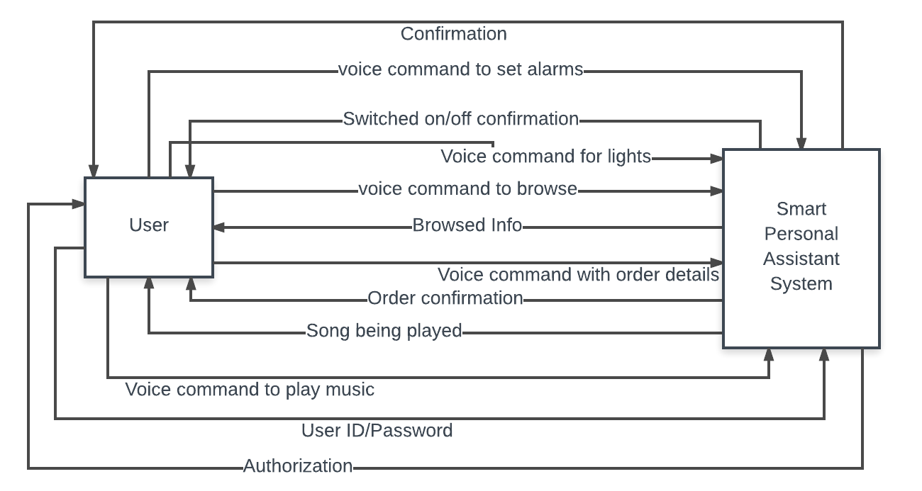 Level 0 diagram ,Level 1 and 2 diagrams

**Context Diagram**

**Diagram 3.8 Level 0 DFD**

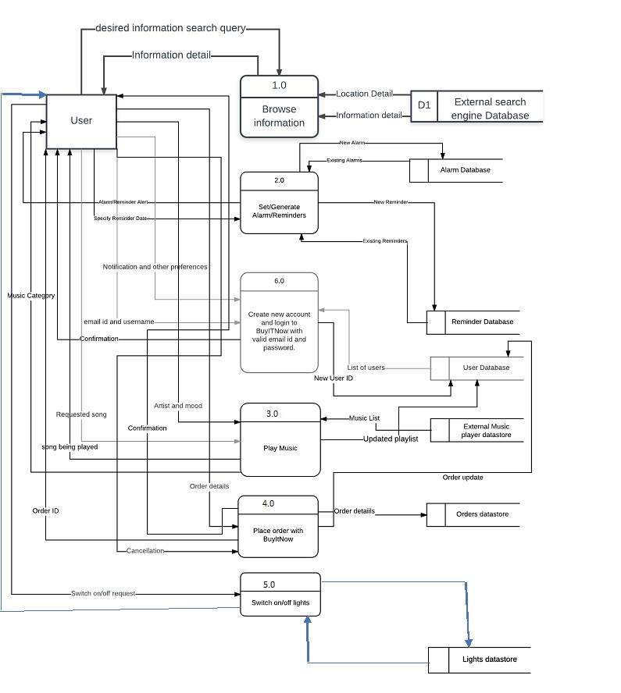

**Diagram 3.9 DFD level l Browse Information**

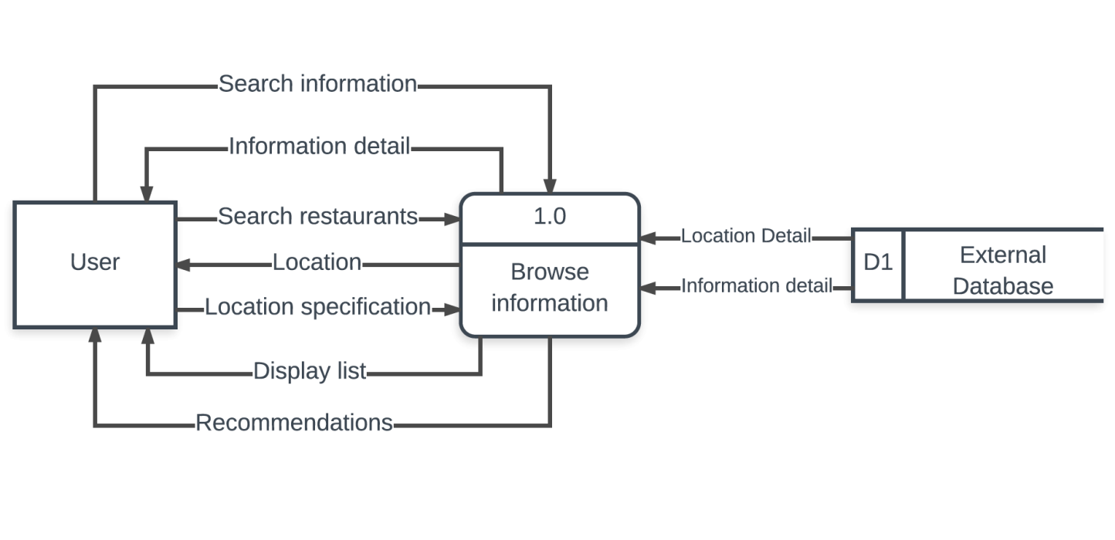

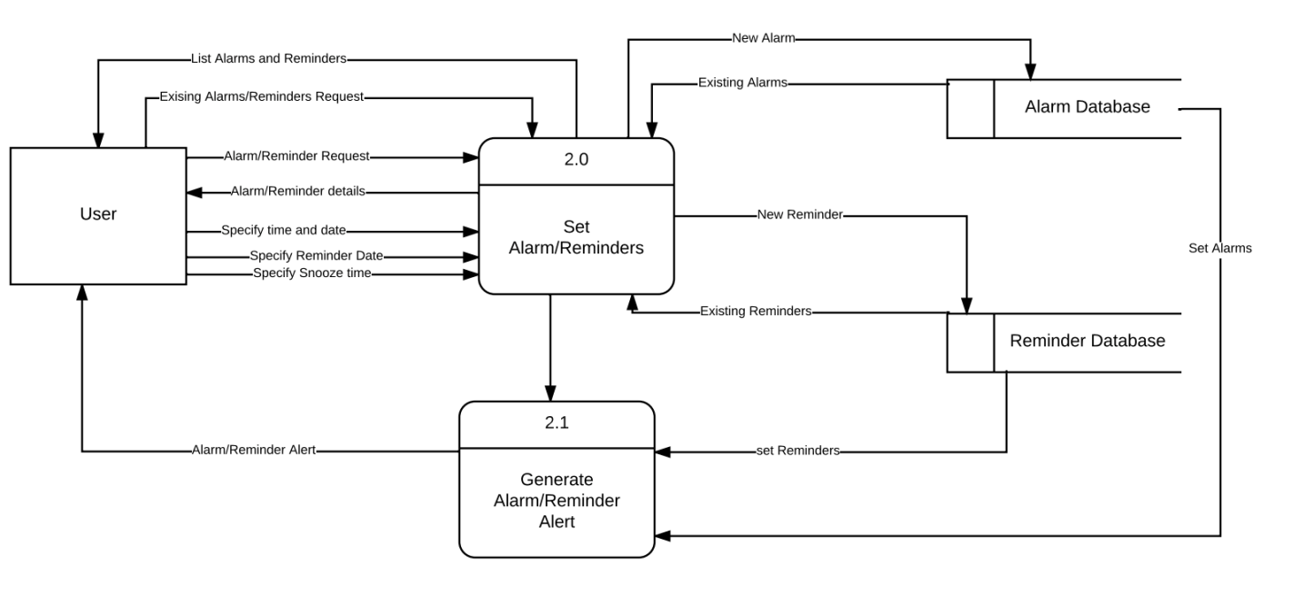

**Diagram 3.10 DFD level 1 Alarm/Remainder Set**

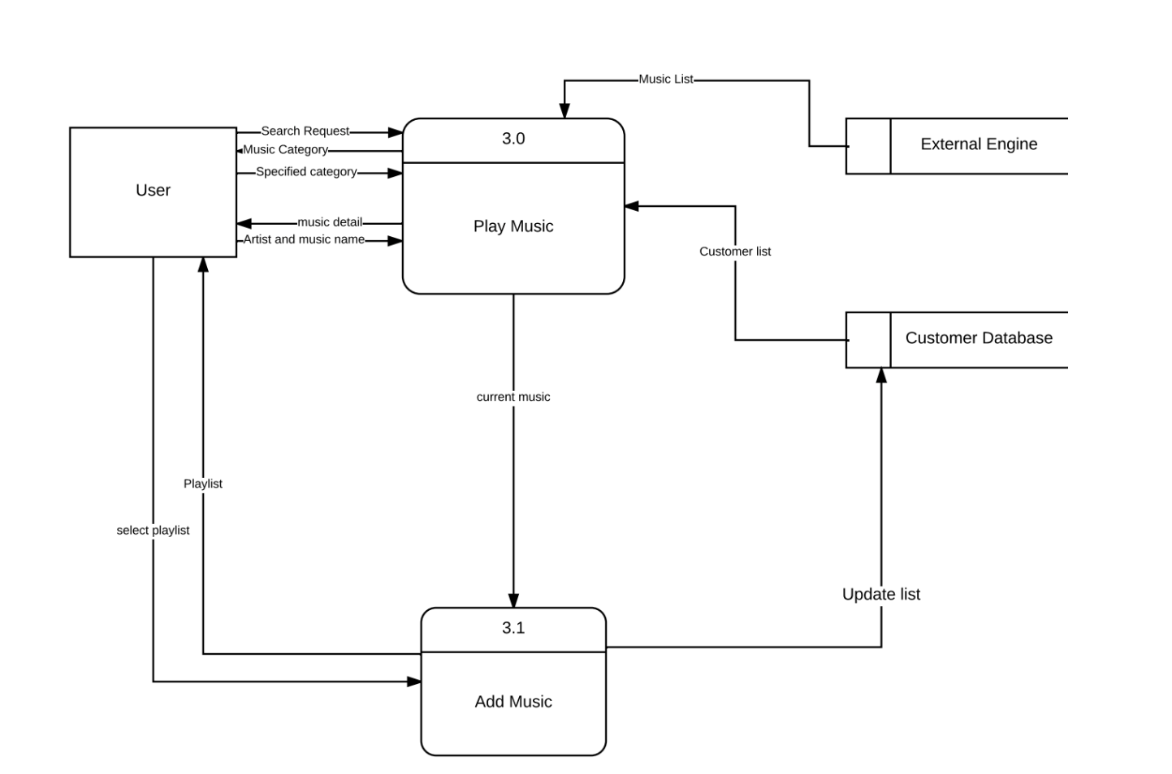

**Diagram 3.11 DFD level l Music Play**

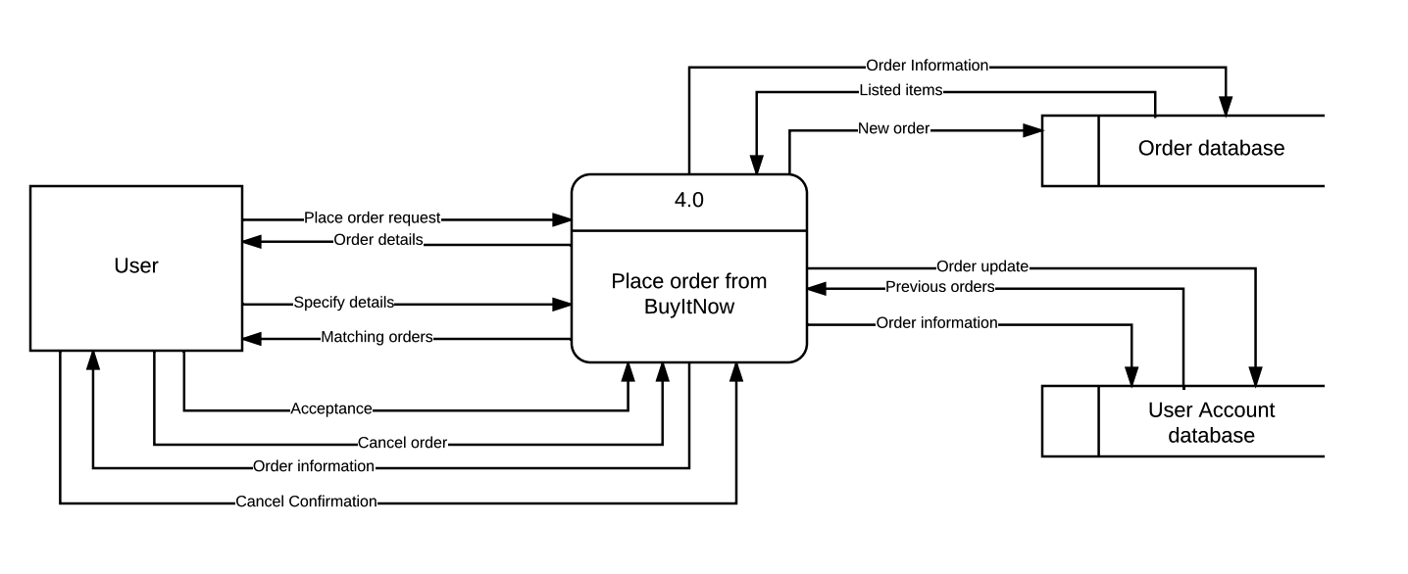

**Diagram 3.12 DFD level l Buy it Now**

**Diagram 3.13 DFD level l Switch on/off Lights** 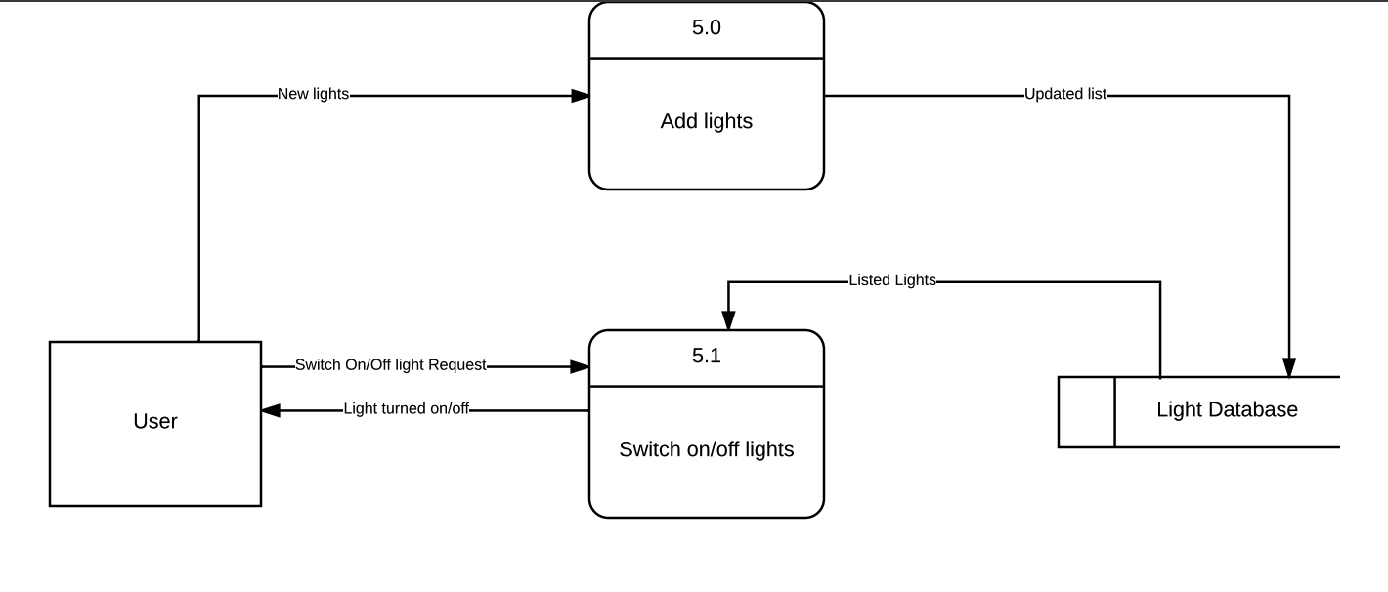

**Diagram 3.14 DFD level l Account Login**

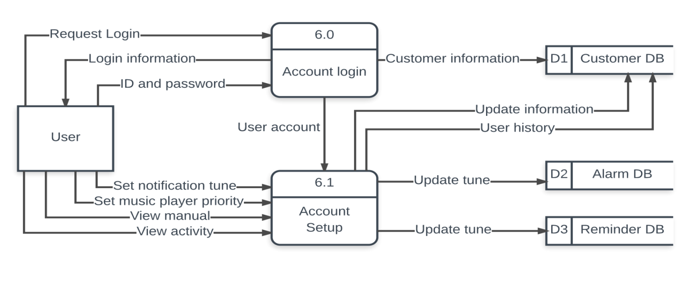

### 3.4 Data Dictionary

**Table 3.2 Data Dictionary**

**Table 3.3 Buy it Now Database**

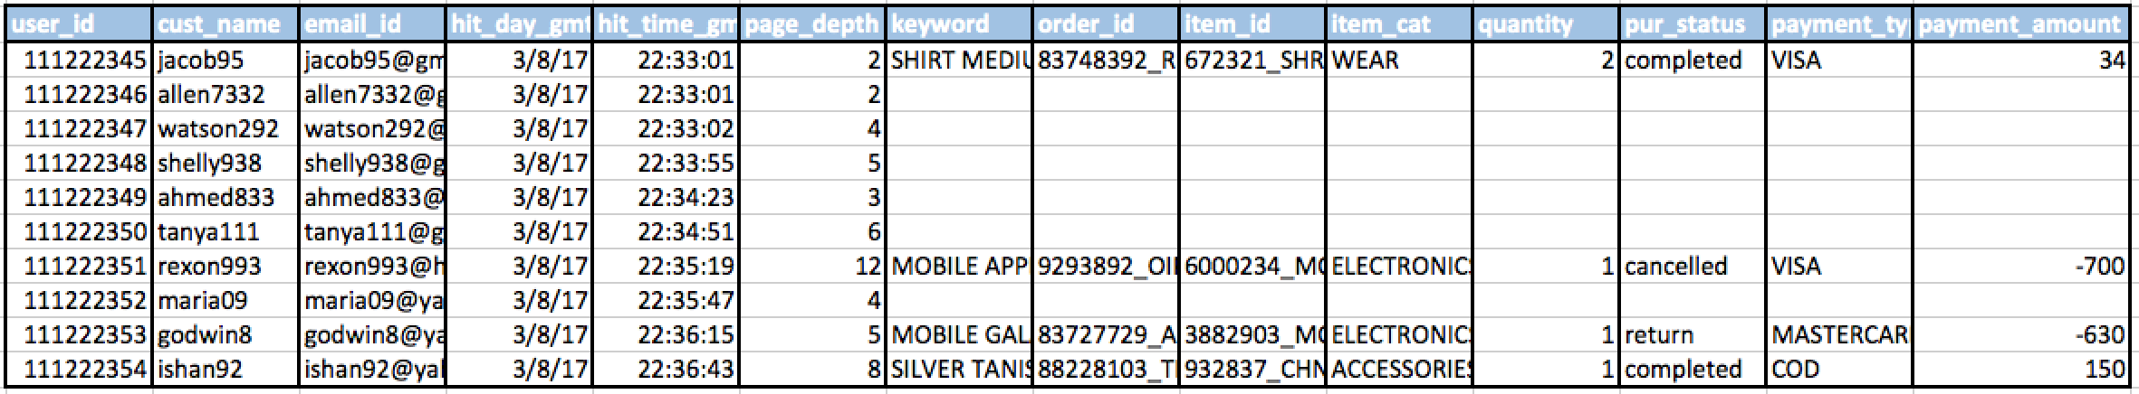

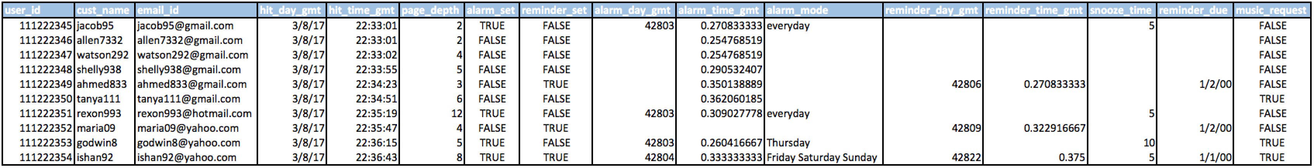

**Table 3.4 Alarm Database**

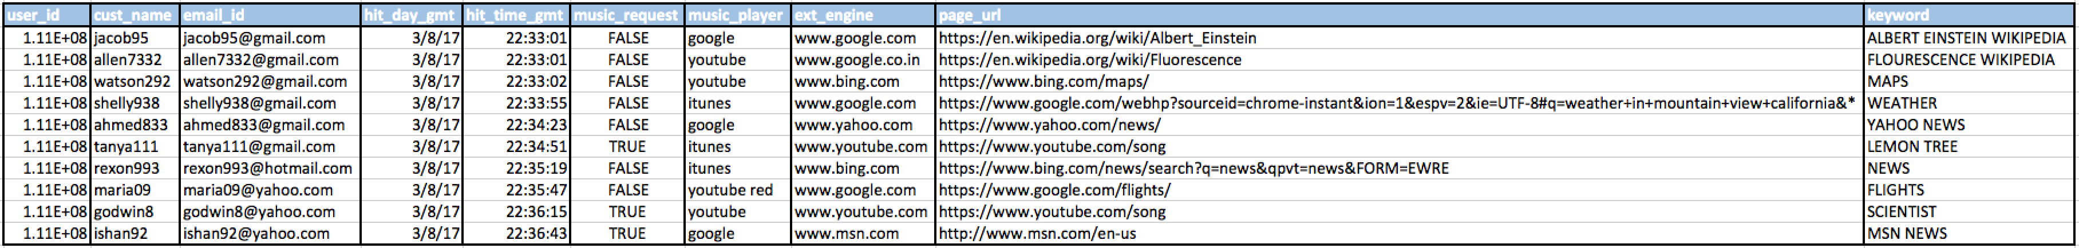

**Table 3.5 External Engine Database**

**Table 3.6 Remainder DB**

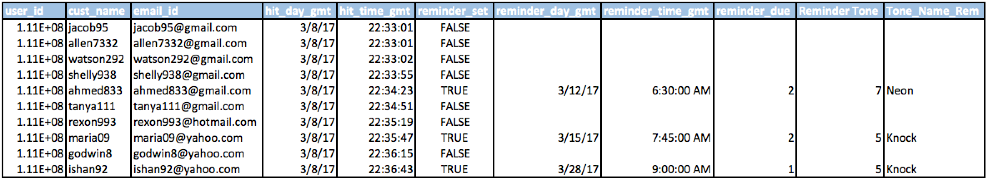

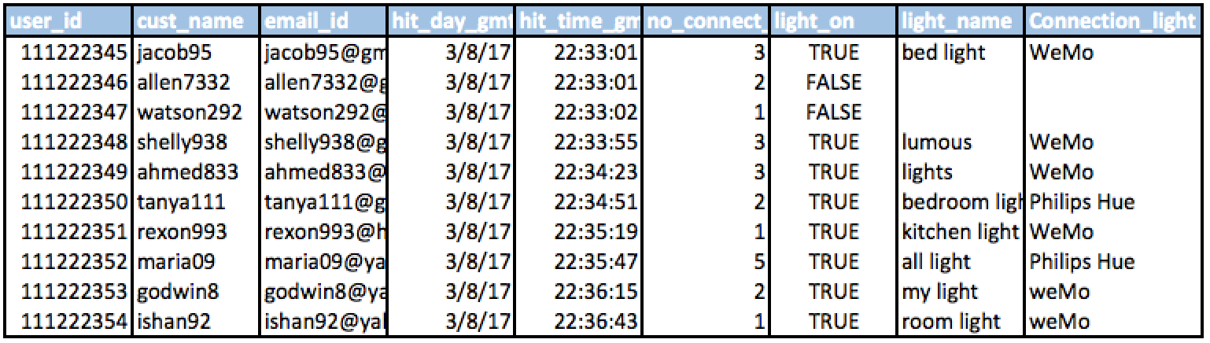  
**Table 3.7 Light Database**

# 

* 1. **UI Templates**

BuyItNow has always strived to provide the best service when it comes to User Experience. With a well efficient User Interface design team, we have come up with a user friendly mobile application that is compatible in all mobile devices. With the swipe technology along with the perfect noise cancellation microphone system and interactive icons, this app makes it easier to navigate from one screen to another.

**Diagram 3.15 Home Screen**

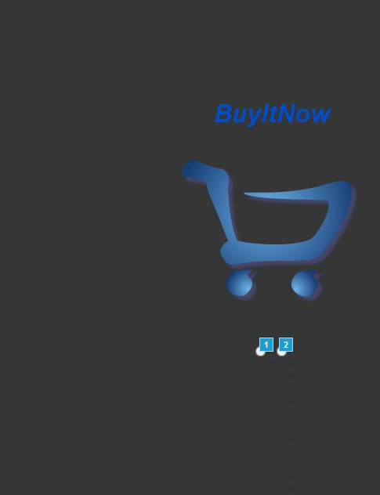

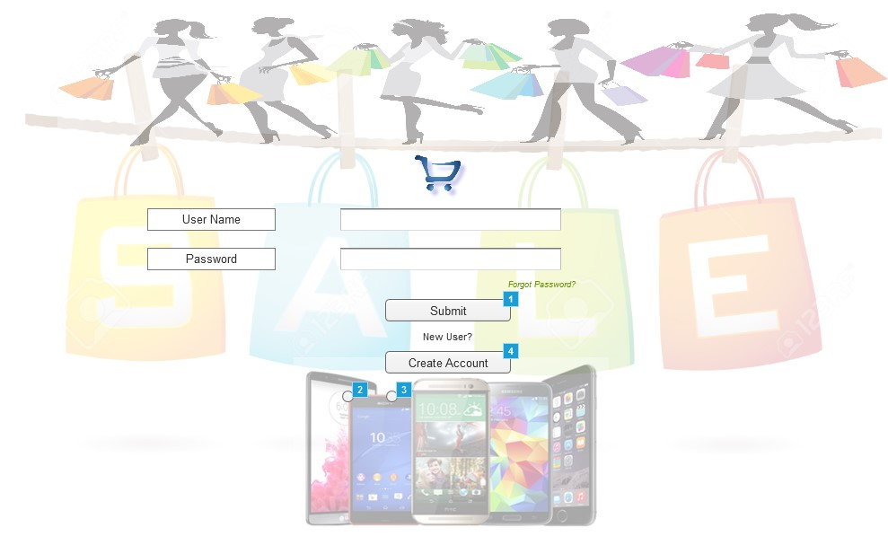**Diagram 3.16 Account Log-in**

**Diagram 3.17 Create Account**

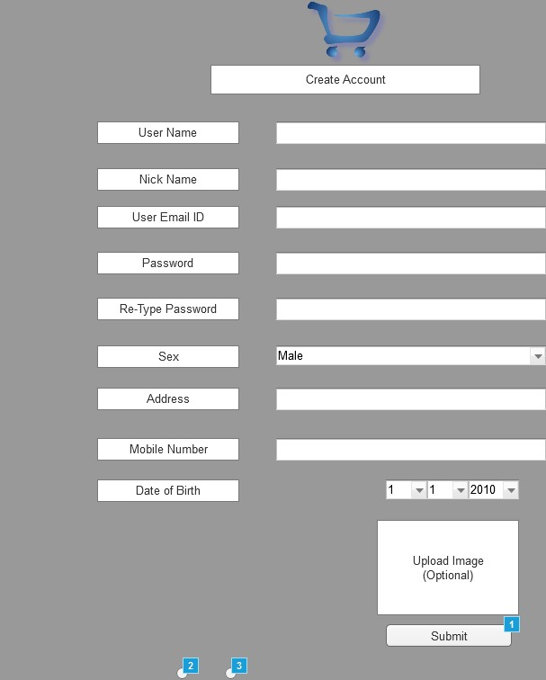

**Diagram 3.18 Voice Command Screen**

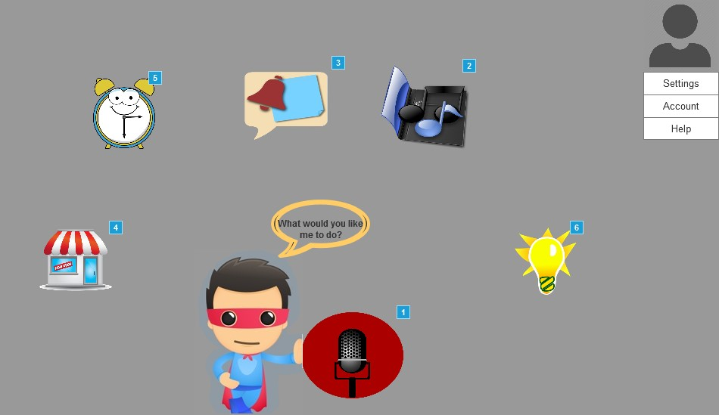

**Diagram 3.19 Voice Recognition Screen**

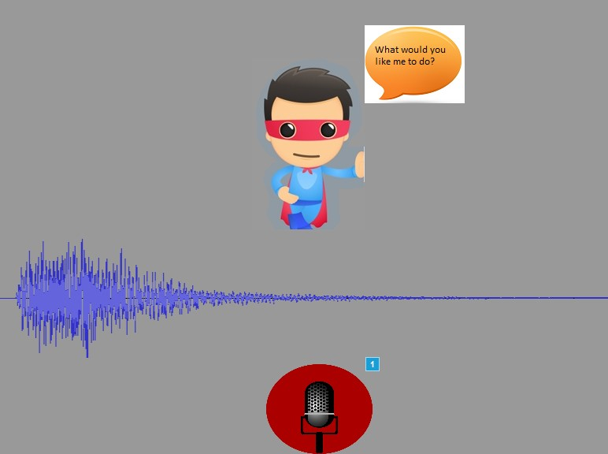

**Diagram 3.20 Alarm Screen**

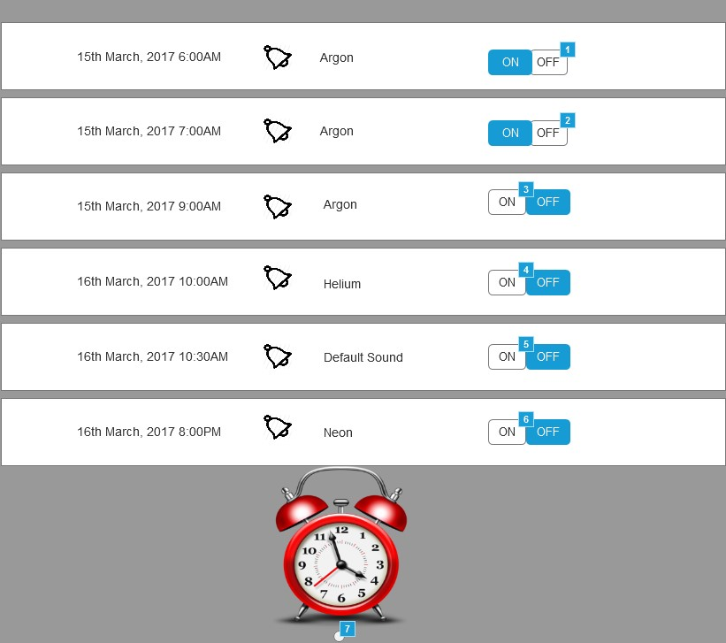

**Diagram 3.21 Remainder Screen UI**

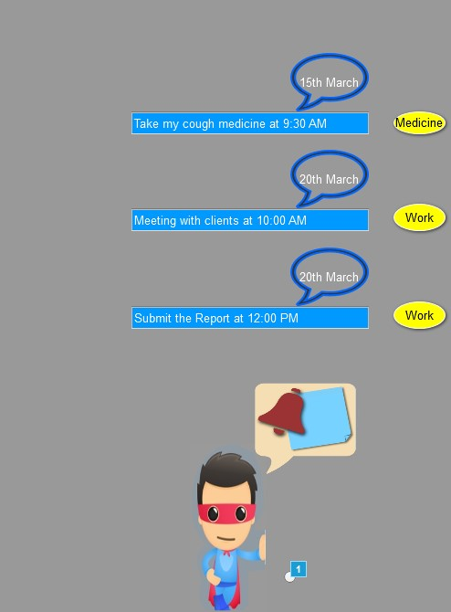

**Diagram 3.22 Music Screen**

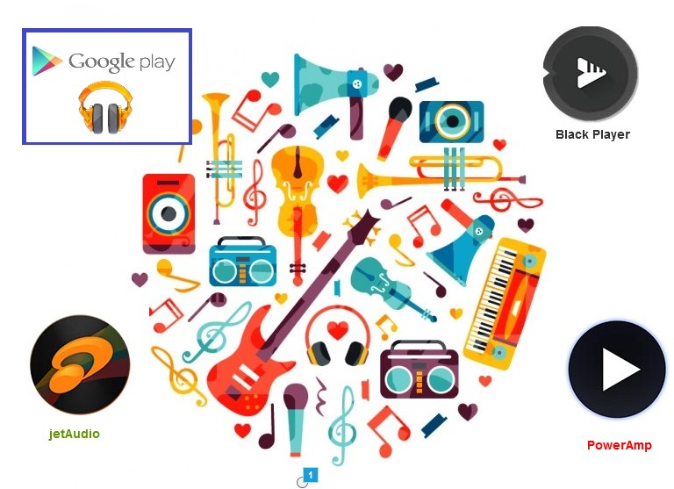

**Diagram 3.23 Order Screen**

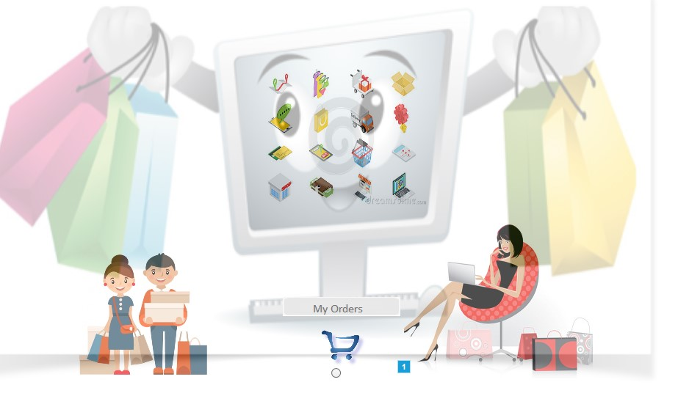

**Diagram 3.24**

